

**Cégep de la Gaspésie et des Îles, Montréal**

**A Project Report**

**Learning Language Application**



**Submitted by**

|  |  |  |
| --- | --- | --- |
| **S.No** | **Student Name** | **Student ID** |
| **1.** | **Buchireddy Nikhil Reddy** | **1995114** |
| **2.** | **Gurpreet Kaur** | **1995088** |
| **3.** | **Shivam Sharma** | **1993471** |
| **4.** | **Gill Jageer Singh** | **1994763** |
| **5.** | **Sangamesh Korwar** | **1994989** |
| **6.** | **Vamsi Krishna Gunjara** | **1894315** |

**Under the guidance of**

**Pargol Poshtareh**

**Sakku Ramanathan**

**Table of Content:**

**1. Project Description** **3**

**2. Scope of the Project** **4**

**3. Functional Requirements** **5**

**4. Non-Functional Requirements** **7**

**5. User Stories** **10**

**6. User Story Backlog** **16**

**7.Release plan** **17**

**8. ScreenShots** **18**

**9. Screen Flow Diagram** **22**

## 

## **1. Project Description**

Considering that autistic children have difficulties in generalization when learning new vocabulary, we want to develop an app that aims to teach autistic children new concepts (animals, colors, shapes, etc.) The app covers learning (teaching) as well as testing (the knowledge level of the child). It also covers three different levels of instructions: Level 1: Learning phase: display simple flash cards with for example 10 cards with different voice tones pronouncing the word. The images should be isolated (background white without environment) representing one concept (example: 10 images of birds in different colors with real photographs and hand-drawn pictures). Testing phase: display a new, different flash card from the learning phase of the same word with other cards of other things (other animals, for example) and ask to point the picture that corresponds to the word, if the response is correct, go to the next level. Level 2: Display pictures with distracting items (example: a bird in a tree, etc.) level 2 also has a Learning phase and a Test phase. Level 3: Play videos about animals, colors, shapes, etc. this level also has a Learning phase and Test phase. This app provide the following functionalities:

* Login for the User
* Sign Up for new users of the Learning Language Application.
* User profile
* Displaying the various types of flash cards and videos based on the level the user is in(Learning phase).
* Testing the user skills on every Level(Testing phase)
* Tracking the user progress based on the level
* User logout

## 

## **2. Scope of the Project**

This Mobile Application is named as “Learning Language Application”. The scope of the application is to provide its users with an interactive interface to learn a language with various activities. Autistic children have difficulties in generalization when learning new Vocabulary, Our purpose is to develop an app that aims to teach autistic children basic Vocabulary for example animals, colors, shapes, etc. The app covers learning (teaching) as well as testing (the knowledge level of the child). We will cover this teaching and testing in three different levels and help the autistic children to understand the basics of language

## 

## **3. Functional Requirements**

|  |  |  |
| --- | --- | --- |
| **Functional Requirements** | | |
| **S.No** | **Name** | **Description** |
| FR-1 | Sign up | Learning Language Application must allow new users to signup using their name, email, password, contact number. |
| FR-2 | Login | Learning Language Application must allow users to Login using their email id and password. |
| FR-3 | Forgot password | The application must allow registered users to reset their password. |
| FR-4 | User profile | The application must allow users to create their profile |
| FR-5 | Level-1(Learning phase) | The user should be able to learn the words using flash cards with isolated images concept |
| FR-6 | Level-1(Testing phase) | The User should be able to test his knowledge based on the level-1 based learning |
| FR-7 | Level-2(Learning phase) | The user should be able to learn the words using flash cards with Distractive images concept |
| FR-8 | Level-2(Testing phase) | The User should be able to test his knowledge based on the level-2 based learning. |
| FR-9 | Level-3(Learning phase) | The user should be able to learn the words using the videos related to the respective elements |
| FR-10 | Level-3(Testing phase) | The User should be able to test his knowledge based on the level-3 based learning. |
| FR-11 | Update profile | Users must have a profile page where they can see and update their current profile information. |
| FR-12 | Progress | The user should be able to track his progress based on his learning |
| FR-13 | Mark Levels as complete | The completed levels should be displayed as completed |
| FR-14 | Logout | Users must be able to logout from the application. |

## 

## 

## 

## 

## **4. Non-Functional Requirements**

|  |  |  |
| --- | --- | --- |
| **Non-Functional Requirements** | | |
| **S. No** | **Name** | **Description** |
| NFR-1 | Performance | The system must be interactive, and the delays involved must be less. |
| NFR-2 | Response Time | The response time should be user friendly. |
| NFR-3 | Security | The user data must be secured |
| NFR-4 | Usability | The application must be easy to handle and navigate in the most expected way with no delays. |
| NFR-5 | Social Media Presence | App provides the Social Media connection to the application |
| NFR-6 | Availability | The system must be available to a large number of users at a single point of time. |
| NFR-7 | Portability | The application must be able to adapt newer versions of Android OS being released. |
| NFR-8 | Maintainability | Application must provide new question every time user start a new test in the app |
| NFR-9 | Database | Fetching and submitting the data into the database must be fast so that queries can handle quickly. |
| NFR-10 | Reliability | Only those activities must be presented to the user which he/she requested. |

## 

## **5. User Stories**

|  |  |
| --- | --- |
| **User story Id** | LL-01 |
| **Name** | As a user, I want to enter my email and password so that I can login into my Learning Language Application. |
| **User story points** | 5 |
| **Priority** | High |
| **Description** | When a user wants to access the Learning Language Application, the user first needs to enter email and password if already registered. |

|  |  |
| --- | --- |
| **User story Id** | LL-02 |
| **Name** | As a user, I want to register first to Learning Language Application with an app so that I can login. |
| **User story points** | 8 |
| **Priority** | High |
| **Description** | When a user wants to access an Learning Language Application. Users need to register with email, name, password, and confirm password. |

|  |  |
| --- | --- |
| **User story Id** | LL-03 |
| **Name** | As a user, I want to access the home page after login |
| **User story points** | 3 |
| **Priority** | High |
| **Description** | When a user is logged-in,the user must be able to view the content available for learning |

|  |  |
| --- | --- |
| **User story Id** | LL-04 |
| **Name** | As a user, I want to access the level-1 to start learning |
| **User story points** | 3 |
| **Priority** | High |
| **Description** | When user logged in, the user must be able to access the level-1 tutorial. |

|  |  |
| --- | --- |
| **User story Id** | LL-05 |
| **Name** | As a user, I want to test my performance based on level-1 based learning |
| **User story points** | 3 |
| **Priority** | Medium |
| **Description** | The user can be able to test his knowledge based on level-1 |

|  |  |
| --- | --- |
| **User story Id** | LL-06 |
| **Name** | As a user, I want to test my performance based on level-2 based learning |
| **User story points** | 5 |
| **Priority** | Medium |
| **Description** | The user can be able to test his knowledge based on level-2 |

|  |  |
| --- | --- |
| **User story Id** | LL-07 |
| **Name** | As a user, I want to test my performance based on level-3 based learning |
| **User story points** | 5 |
| **Priority** | High |
| **Description** | The user can be able to test his knowledge based on level-3 |

|  |  |
| --- | --- |
| **User story Id** | LL-08 |
| **Name** | As a user, I can be able to update my profile |
| **User story points** | 5 |
| **Priority** | Low |
| **Description** | The user can be able to update his profile |

|  |  |
| --- | --- |
| **User story Id** | LL-09 |
| **Name** | As a user, I can able to Track my progress |
| **User story points** | 3 |
| **Priority** | Medium |
| **Description** | The user can be able to track his progress |

|  |  |
| --- | --- |
| **User story Id** | LL-10 |
| **Name** | As a user, I want to able to see the completed levels |
| **User story points** | 2 |
| **Priority** | Medium |
| **Description** | The user can able to view the completed levels as marked |

|  |  |
| --- | --- |
| **User story Id** | LL-11 |
| **Name** | As a user, I want to logout from the application when required |
| **User story points** | 2 |
| **Priority** | Medium |
| **Description** | The user can logout by clicking the logout button |

|  |  |
| --- | --- |
| **User story Id** | LL-12 |
| **Name** | As an admin, I want to enter my email and password so that I can login into Learning Language application (admin mode) |
| **User story points** | 5 |
| **Priority** | High |
| **Description** | As an admin, I want to enter my email and password so that I can login into Learning Language application (admin mode) |

|  |  |
| --- | --- |
| **User story Id** | LL-13 |
| **Name** | As an admin, I want to see the all users account in a list view. |
| **User story points** | 5 |
| **Priority** | High |
| **Description** | As an admin, I want to see the all users account in a list view. |

|  |  |
| --- | --- |
| **User story Id** | LL-14 |
| **Name** | As an admin, he/she can add or delete images and videos for Learning Levels |
| **User story points** | 5 |
| **Priority** | High |
| **Description** | As an admin, he/she can add or delete images and videos for Learning Levels |

|  |  |
| --- | --- |
| **User story Id** | LL-15 |
| **Name** | As an admin, he/she can manage user(add or delete user’s account) |
| **User story points** | 8 |
| **Priority** | High |
| **Description** | As an admin, he/she can manage user(add or delete user’s account) |

## 

## **6.User Story Backlog**

|  |  |  |  |
| --- | --- | --- | --- |
| ID | Name | USP | Priority |
| LL-1 | As a user, I want to enter my email & password so that I can login into my Learning Language application | 5 | High |
| LL-2 | As a user, I want to register first to learning Language with an app so that I can login. | 8 | High |
| LL-3 | As a user, I want to reset my password | 3 | High |
| LL-4 | As a user, I want to access the level-1 to start learning | 3 | High |
| LL-5 | As a user, I want to test my performance based on level-1 based learning | 3 | Medium |
| LL-6 | As a user, I want to test my performance based on level-2 based learning | 5 | Medium |
| LL-7 | As a user, I want to test my performance based on level-3 based learning | 5 | High |
| LL-8 | As a user, I can be able to update my profile | 5 | Low |
| LL-9 | As a user,I can able to see my progress of the learning course | 3 | Medium |
| LL-10 | As a user, I want to able to see the completed levels | 2 | Medium |
| LL-11 | As a user, I want to logout from the application when required | 2 | Medium |
| LL-12 | As an admin, I want to enter my email and password so that I can login into Learning Language application (admin mode) | 5 | High |
| LL-13 | As an admin, I want to see all users' accounts in a list view. | 5 | High |
| LL14 | As an admin, he/she can add or delete images and videos for Learning Levels | 5 | High |
| LL-15 | As an admin, he/she can manage user(add or delete user’s account) | 8 | High |

## 

## 

## 

## 

## **7.Release Plan**

|  |  |  |
| --- | --- | --- |
| **S. NO:** | **DELIVERABLES** | **DEADLINE** |
| 1 | Project Deception, Scope of Project, Functional Requirements Non-Functional Requirements, User stories, User Stories Backlog Table, sample screens and flow diagram. | 19/01/2021 |
| 2 |  |  |
| 3 |  |  |
| 4 |  |  |

## **8. ScreenShots**

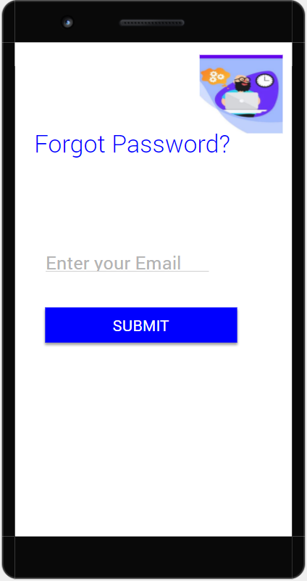

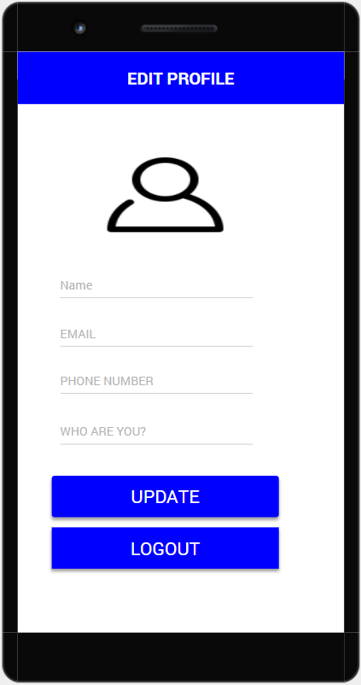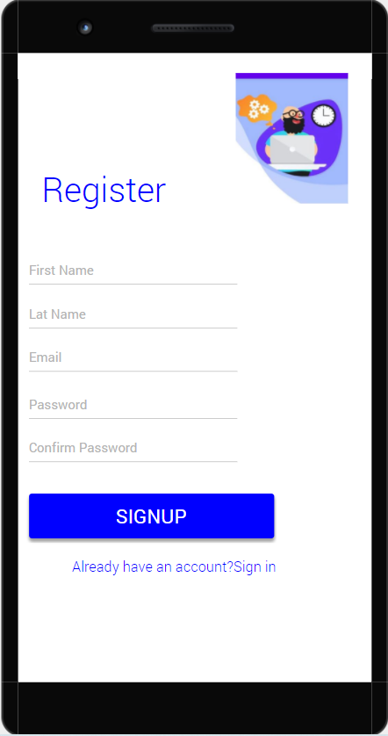

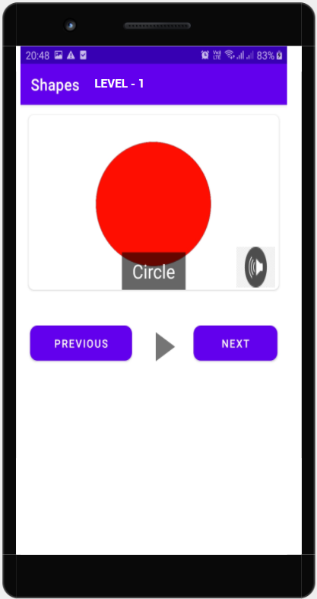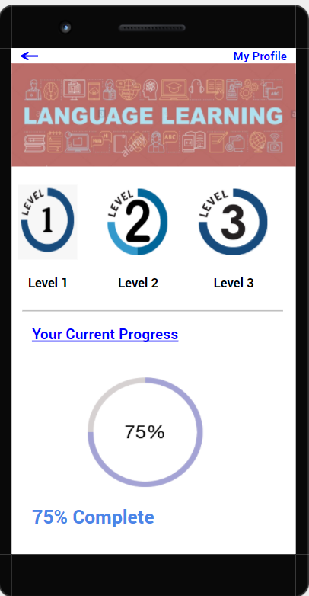

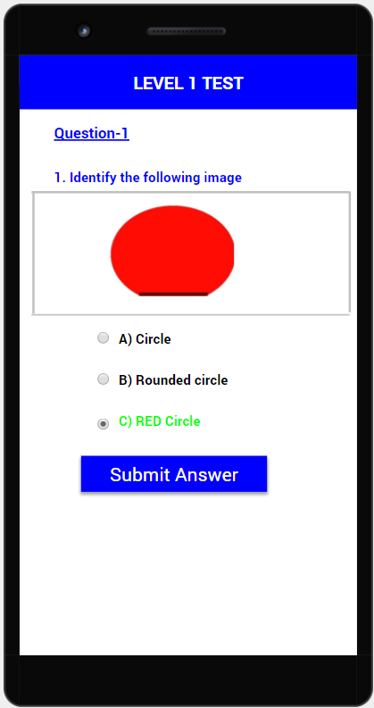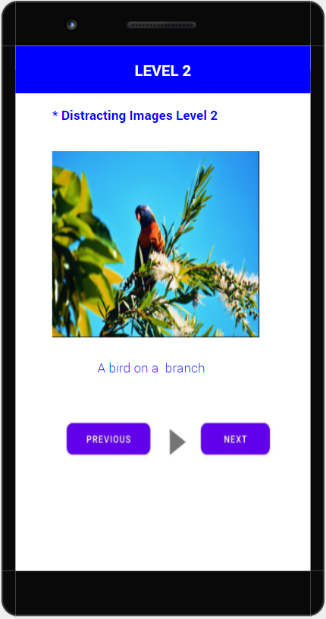

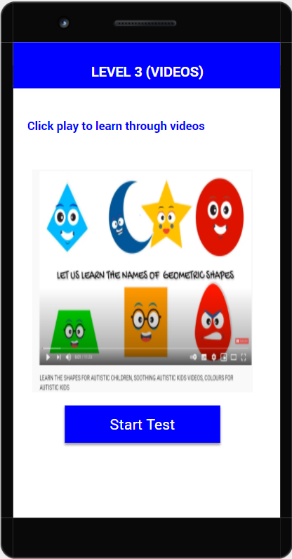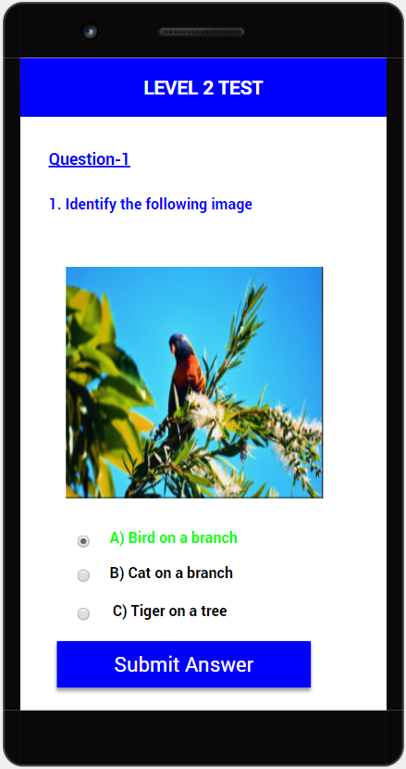

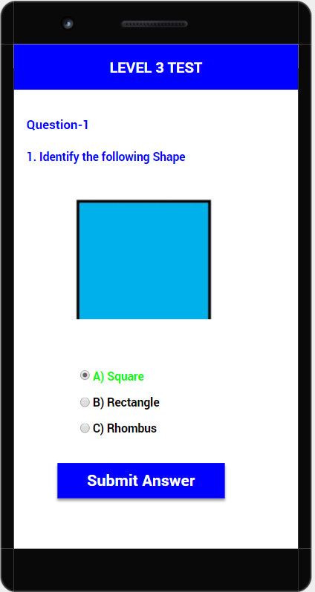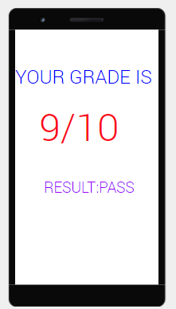



## 

## 

## 

## **9. Screen Flow Diagram**

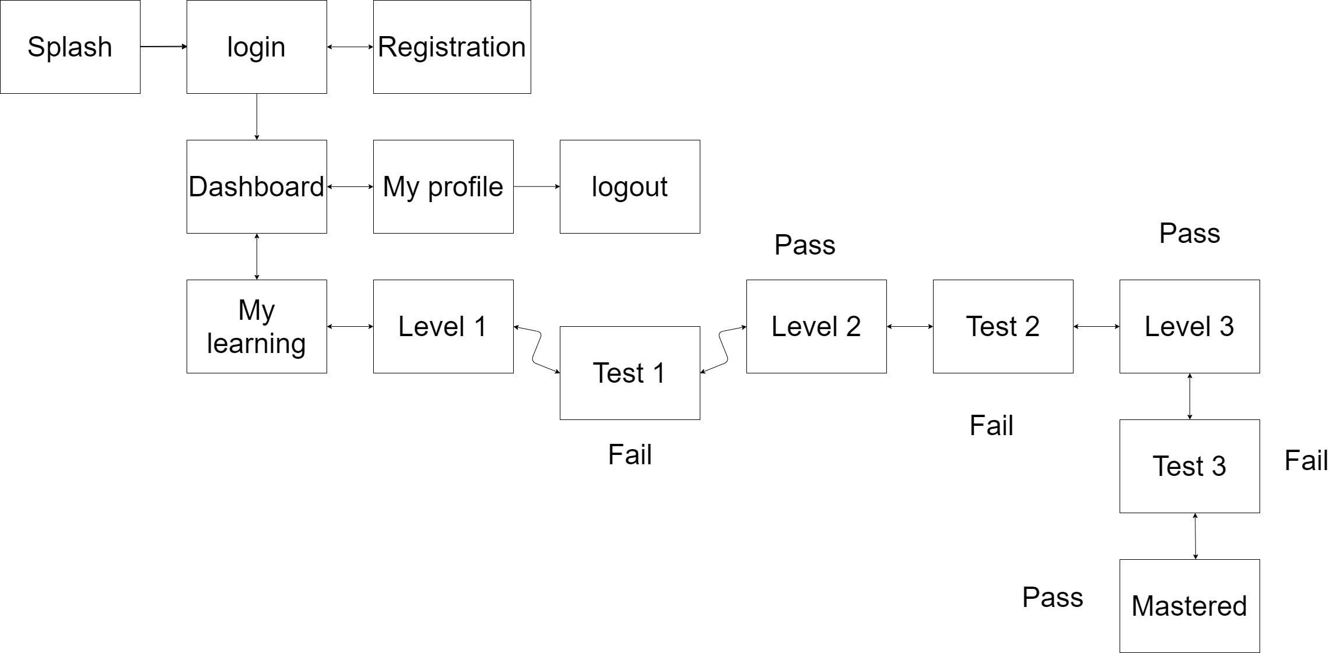

## **10. Use Case Diagram**

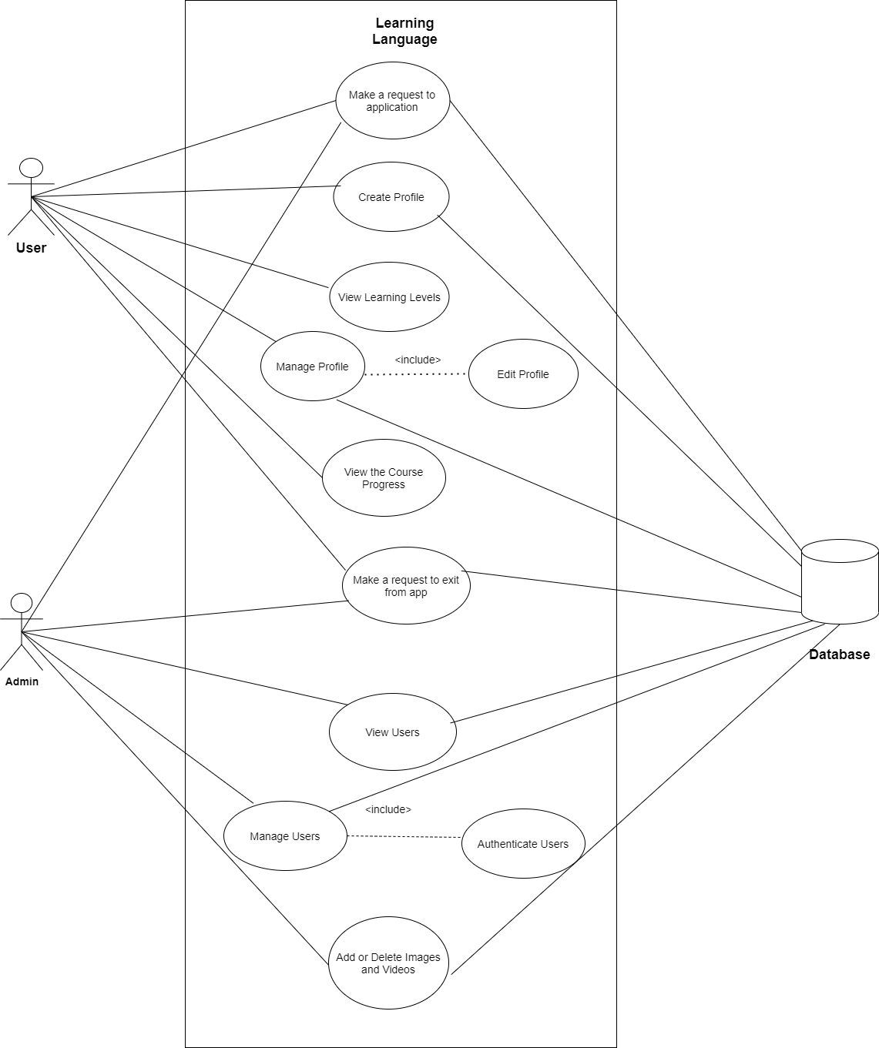

## **11.Fully Dressed Use Case:**

1. Login:

|  |  |
| --- | --- |
| System | A mobile application: Learning Language |
| Identifier | UC- 01 |
| Author(s) | Team 1 |
| Version | None |
| Name | The user is registered and has an account on Learning Language Application. |
| Pre-Condition(s) | The user is already registered but does not log in. |
| Post-Condition(s) | The user is directed to the Home Page of the application. |
| Trigger | The user has clicked on the Login button. |
| Normal Flow | 1. User enters the email and the password in the Login form.  2. User clicks on the Login button.  3. User is directed to the homepage of the application. |
| Alternate Flow | 1. User clicks on forget password.  2. User enters the email used for registration.  3. An OTP is sent to the given email address.  4. User changes the password and confirms the changes.  5. User is directed to the Login page.  6. User enters the user name and the password in the form.  7. User is directed to the homepage specific to the user |
| Exceptional Flow(s) | The password should be a minimum 6 characters. The system will prompt the message “Password is short, it should be at least 6 characters” on the application display.  The system will prompt the message “Email is not registered”.  The system will prompt the message “Email and Password required”. |
| Related Actor(s) | Primary-Registered User |
| Related Use Case(s) | Register |

## 2. Register:

|  |  |
| --- | --- |
| System | A mobile application: Learning Language |
| Identifier | UC- 02 |
| Author(s) | Team 1 |
| Version | None |
| Name | Register New User |
| Pre-Condition(s) | The user is non-registered and does not have an account on Learning Language application |
| Post-Condition(s) | The user is directed to the Login page of the application. |
| Trigger | The user has clicked on Create a New Account. |
| Normal Flow | 1. User clicks on the Create a New Account to create the user profile.  2. User enters the details in the form and sets up the email and password.  3. User clicks on the Create new Account Text.  4. User is redirected to the login Page. |
| Alternate Flow | None |
| Exceptional Flow(s) | Exception: Only unregistered emails can be used for registration.  1. The system will prompt the message “Email has already been registered, enter new email”.  2. The password should be a minimum 6 characters.  3. The system will prompt the message “Password is short, it should be at least 6 characters” on the application display.  4. The system will prompt the message “Email and Password required” |
| Related Actor(s) | Primary-Non-Registered User |
| Related Use Case(s) | Login |

3. Reset Password:

|  |  |
| --- | --- |
| System | A mobile application: Learning Language |
| Identifier | UC- 03 |
| Author(s) | Team 1 |
| Version | None |
| Name | Reset Password. |
| Pre-Condition(s) | The user is registered and has an account on an application. |
| Post-Condition(s) | None |
| Trigger | The user has clicked on the Forget Password text. |
| Normal Flow | 1. User clicks on the Forget Password text..  2. User enters the email used for registration.  3. User clicks on the reset password button.  4. Users will change passwords using links received by email.  5. User is redirected to the Login Page. |
| Alternate Flow | None |
| Exceptional Flow(s) | Exception: Password should be a minimum 6 character.  1. The system will prompt the message “Password is too short, it should be at least 6 characters”.  2. The system will prompt the message “Email is not registered with application”. |
| Related Actor(s) | Primary-Registered User |
| Related Use Case(s) | Login |

4.View Learning Level

|  |  |
| --- | --- |
| System | A mobile application: Learning Language |
| Identifier | UC- 04 |
| Author(s) | Team 1 |
| Version | None |
| Name | View Learning Level |
| Pre-Condition(s) | The user is registered and has an account on an application. |
| Post-Condition(s) | The User can access the Learning Level 1 |
| Trigger | On Home-page user has clicked on the Learning Level 1. |
| Normal Flow | 1. Users click on Learning Level 1.  2. The details of the Leaning Level 1 will arrive on the screen. |
| Alternate Flow | None |
| Exceptional Flow(s) | None |
| Related Actor(s) | Primary-Registered User |
| Related Use Case(s) | None |

5. Update Profile:

|  |  |
| --- | --- |
| System | A mobile application: Learning Language |
| Identifier | UC- 05 |
| Author(s) | Team 1 |
| Version | None |
| Name | Update Products |
| Pre-Condition(s) | The user is registered and has an account on an application. |
| Post-Condition(s) | None |
| Trigger | The user has clicked on the Edit Profile button. |
| Normal Flow | 1. Users click on My Profile Text.  2. The details of the user's profile will arrive on the screen.  3. A User can edit his/her details on the profile. |
| Alternate Flow | None |
| Exceptional Flow(s) | None |
| Related Actor(s) | Primary-Registered User |
| Related Use Case(s) | None |

## **12 .Activity diagram**

